M2 API:
API | End Point and URL | Observation
HIP Initiate Linking | - hiecm/v3/token/generate-token  - hiecm/hip/v3/link/carecontext  - Link Care Context Notify | ABDM Developer Portal | Done
 | - hiecm/hip/v3/link/carecontext
 | - Link Care Context Notify | ABDM Developer Portal  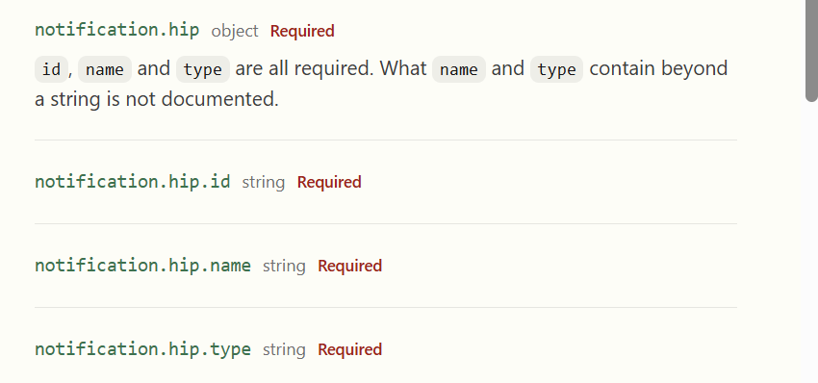 | Only one is required not all
 | - /hiecm/hip/v3/link/patient/links/sms/notify2 | Done
User Initiate Linking | - Discovery  - On Discovery, HIP responds with found care contexts | ABDM Developer Portal | Need To Update Correct curl:  curl --location 'https://dev.abdm.gov.in/api/hiecm/user-initiated-linking/v3/patient/care-context/on-discover' \  --header 'REQUEST-ID: 4cd3649a-3ed0-4b30-8da0-5b41b5c85198' \  --header 'TIMESTAMP: 2026-09-15T07:39:02.089Z' \  --header 'X-CM-ID: sbx' \  --data-raw '{  "transactionId": "d0b865a0-4571-4926-8941-258febd4ff74",  "patient": [  {  "referenceNumber": "91178386101731@sbx",  "display": "HIECM-HIP-LTI_20240226_1",  "careContexts": [  {  "referenceNumber": "39c7b7c4-20e3-4302-904b-7f61dc510d06",  "display": "Urine Test"  }  ],  "hiType": "Prescription",  "count": 1  }  ],  "matchedBy": [  "MR"  ],  "response": {  "requestId": "25040d98-b4d2-4531-9496-95cc70510e39"  }  }'
 | - hiecm/user-initiated-linking/v3/link/care-context/on-init | Done
 | - hiecm/user-initiated-linking/v3/link/care-context/on-confirm  - Link On-Confirm, HIP confirms linked care contexts | ABDM Developer Portal  - 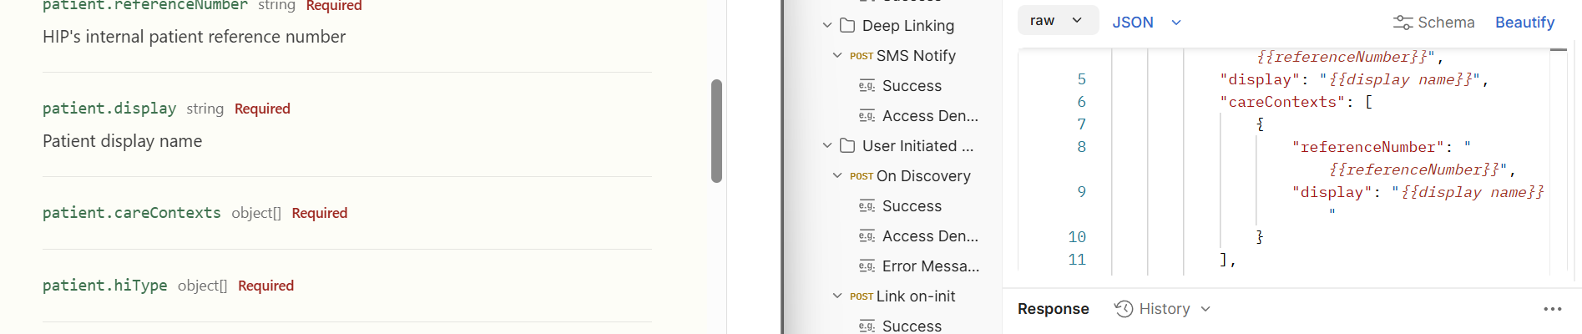 | Need to mention about  Object member of care context object like in:  "careContexts": [  {  "referenceNumber": "{{referenceNumber}}",  "display": "{{display name}}"  }
Data Transefer | - hiecm/consent/v3/request/hip/on-notify  - Acknowledge a consent notification, as the HIP | ABDM Developer Portal  - 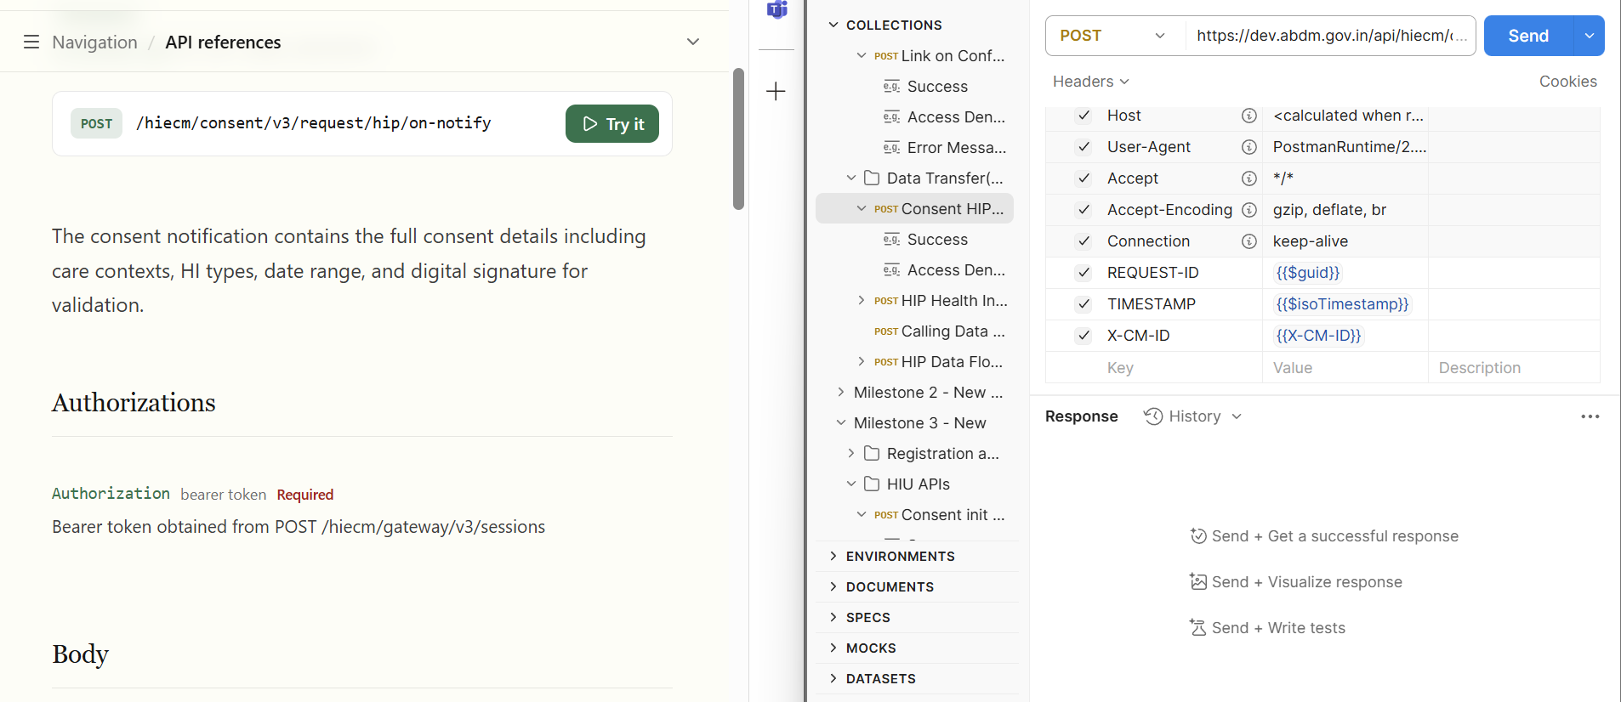 | Need to update below points:  Headers as mentioned in image and link  Curl also needs to update
 | - hiecm/data-flow/v3/health-information/hip/on-request  - Acknowledge a health information data request | ABDM Developer Portal  - 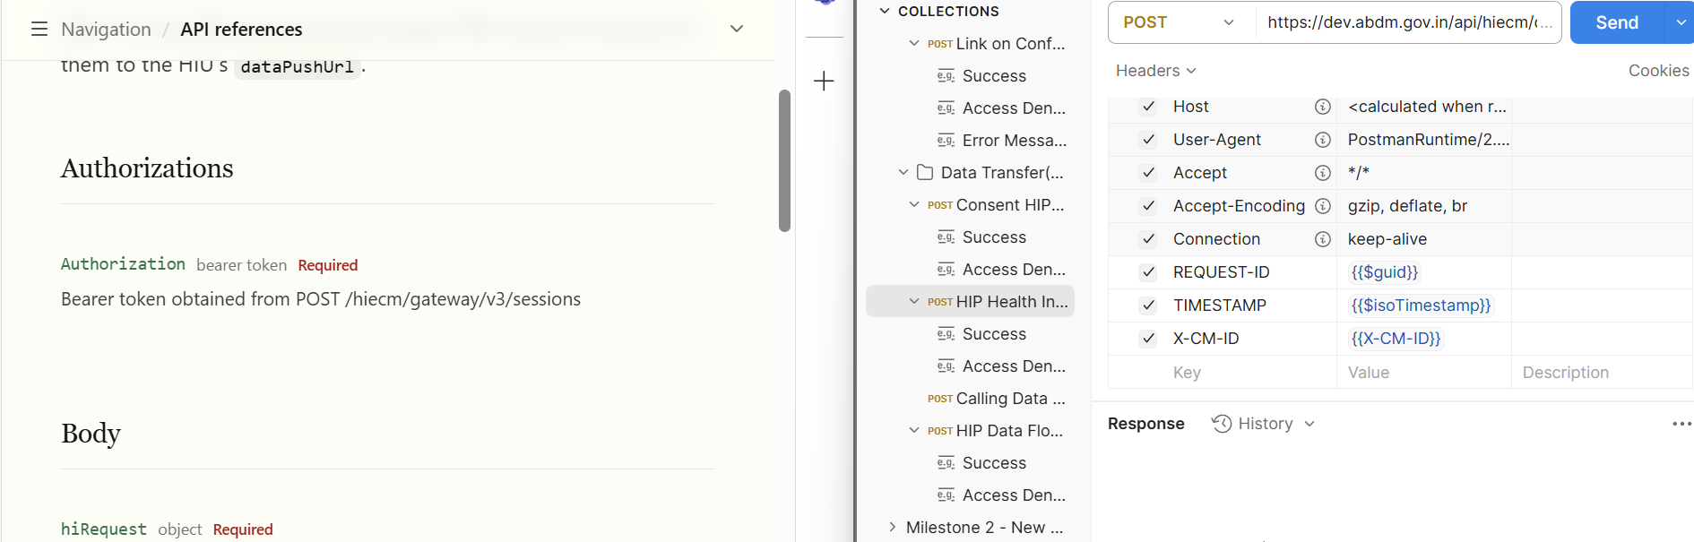 | Need to update below points:  Headers as mentioned in image and link  Curl also needs to update
 | - https://dev.abdm.gov.in/api-hiu/data/notification  - /hiecm/data-flow/v3/health-information/notify  - 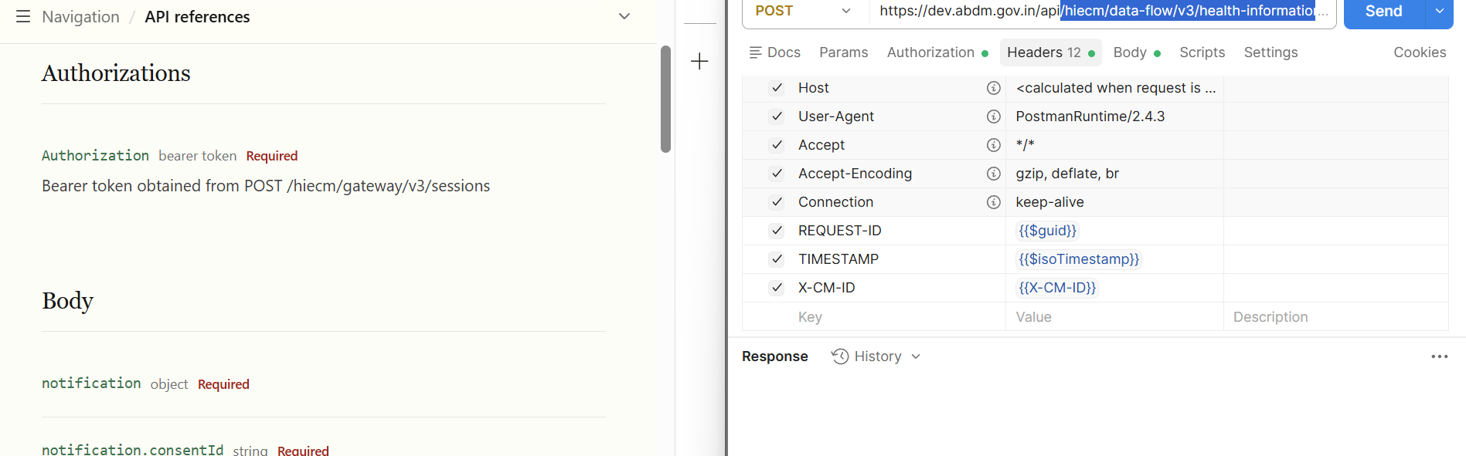 | Need to update below points:  Headers as mentioned in image and link  Curl also needs to update
Callbacks | - Callback: /api/v3/hip/token/on-generate-token | Done
 | - Callback: /api/v3/link/on_carecontext | Done
 | - Callback: /api/v3/consent/request/hip/notify | Missing
 | A discovery request for a patient you may hold records for | ABDM Developer Portal | Missing sequence and multiple callbacks reference here SandBox

M3 APIs:
API | End Point and URL | Observation
- /api/hiecm/consent/v3/request/init | consent.hip.namestringRequired  HIP display name.  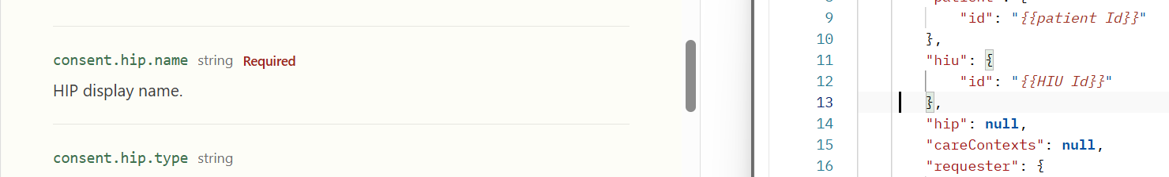 | HIU name not required  Same correction in curl as well
 | /api/hiecm/consent/v3/request/status | Done
 | /api/hiecm/consent/v3/request/hiu/on-notify | Done
 | Acknowledge a consent notification, as the HIU | ABDM Developer Portal  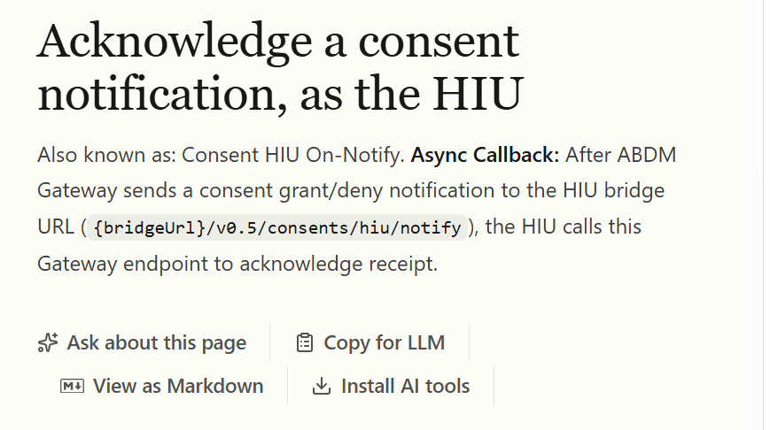 | Change URL ver  V0.5 to v3
 | api/hiecm/consent/v3/fetch | Done
 | /api/hiecm/data-flow/v3/health-information/request  Request a patient's health information | ABDM Developer Portal  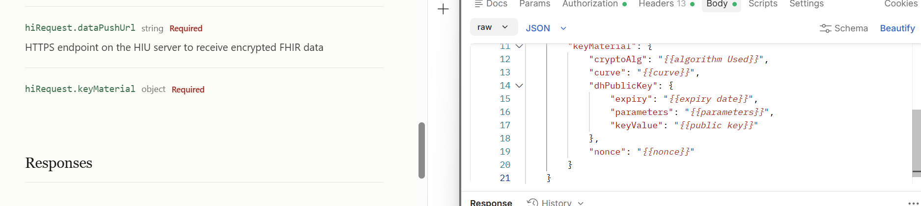 | Explain all key materials in request body
 | /hiecm/data-flow/v3/health-information/notify | Done
Callback URLs | Callback: /api/v3/hiu/consent/request/on-init  Callback: /api/v3/hiu/consent/request/on-status  Callback: /api/v3/hiu/consent/on-fetch  Callback: /api/v3/hiu/consent/request/notify  Callback: /api/v3/hiu/health-information/on-request  Callback: /health-information/transfer | Done

